Application-Oriented Bioprocessing for Advanced Water Resource Recovery
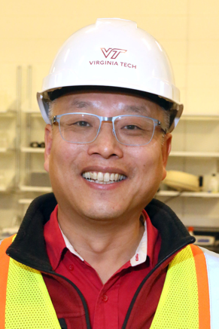
Biosketch: Dr. Zhiwu (Drew) Wang is an Assistant Professor in the Department of Biological Systems Engineering at Virginia Polytechnic Institute and State University (Virginia Tech). He is also a Director leading a “Center for Applied Water Research and Innovation (CAWRI)” for developing advanced technologies to meet the industrial needs of sustainable wastewater management and to become a role model for University-Utility cooperation in the U.S. Dr. Wang’s research has been supported by $7M grants received from federal and industrial sponsors. As a professional engineer, Dr. Wang’s research focuses on developing useful technologies for advanced wastewater treatment and resource recovery. His diverse research portfolio covers aerobic granulation, anaerobic digestion, biological nutrient removal/recovery, as well as biofuel and bioproduct production from a wide spectrum of wasted materials. His research has been performed in close collaboration with utilities, consulting firms, national laboratories, and other higher education institutions with an overarching goal to promote water technology ideation, development, and application.

Abstract: For industrial application, the productivity and profitability of a biotechnology are critically important and can be improved through bioprocess intensification and integration. Dr. Wang will present the status quo using advanced cell immobilization, pretreatment, and smart control technologies for increasing the volumetric productivity of bioreactors dedicated for wastewater treatment and biofuel/bioproduct fermentation. The profitability of these intensified bioprocesses can be increased through their integration with other cutting-edge technologies pilot-tested in Dr. Wang’s lab for mainstream anammox, potable water reuse, food waste-to-bioplastics conversion, and municipal solid waste-to-biofuel conversion. To promote these biotechnologies to full-scale applications for a circular economy, a virtuous circle of research and innovation needs to be nurtured through the close collaboration between University and Industry. The approaches to nurturing such an industrial partnership and their real-world impact will be highlighted in this seminar.

