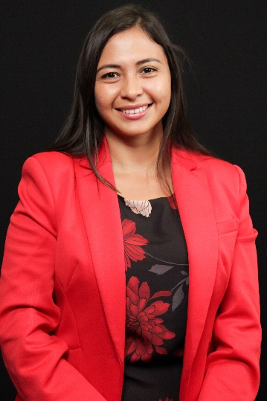

Title: Engineering in vitro models for gynecological diseases

Abstract:
Cell-based high-throughput screening assays are widely used in drug discovery for target identification and validation, drug screening, and drug efficacy and are critical to the burgeoning field of personalized medicine. Historically, a monolayer of cells seeded on tissue culture plastic has been the only practical solution for high-throughput screening of hundreds of compounds and have proven to be an effective tool in the drug development pipeline. However, these two-dimensional (2D) monolayer models cannot capture biophysical cues present in the native tissue, such as cell-cell and cell-matrix interactions, making them poor models for predicting drug response for diseases such as cancer. This represents a critical technology gap, as cancer metastasis is driven by tumor invasion and blood vessel formation. Thus anti-cancer drugs that can target these two processes would have immediate clinical relevance. To overcome these limitations, there is a growing appreciation for complex three-dimensional (3D) tissue-engineered constructs for cancer drug discovery. We developed a novel 3D multilayer multicellular in vitro model of cervical and endometrial cancer. Using design of experiments (DOE), we found two hydrogel formulations that can capture biological cues from the tumor microenvironment. Our optimized matrices for cervical and endometrial cancers achieved significantly greater microvessel formation and cancer invasion compared to Matrigel, the current gold standard for preclinical cancer drug screening platforms. Additionally, we demonstrated that both cancer and endothelial cells must be present for these cellular processes to occur and that each cancer type strongly preferred their own optimized matrices.

Short biography:
I'm a 4th-year Ph.D. candidate in the Chemical Engineering department with a graduate minor in pharmaceutical sciences. I finished my bachelor's in Chemical Engineering from Universidad San Francisco de Quito and joined the Fogg lab in 2019. Dr. Kaitlin Fogg and I have worked on designing in vitro models that can help improve understanding of disease progression and find better treatment methods for women's diseases such as cervical cancer.

